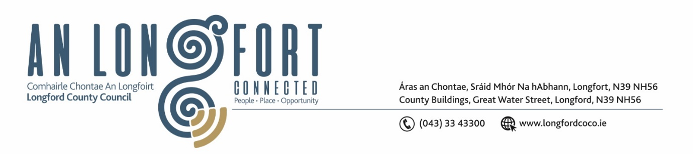

***Please note meeting will be held in the Council Chamber and via Microsoft Teams.***

4 Deireadh Fómhair 2023

**Chuig: Gach Ball don Chomhairle**

A Chomhairleoir,

Iarrtar ort bheith i láthair ag Cruinniú Míosuil Chomhairle Chontae Longfoirt a tionólfar i Seomra na Comhairle, Aras an Chontae, Longford agus via MS Teams are an **Chéadaoin 11ú Deireadh Fómhair 2023 ag 4pm** chun gnó a dhéanamh d’réir an Chláir thíos.

You are requested to attend the Monthly Meeting of Longford County Council to be held in the **Council Chamber and via Microsoft Teams** on **Wednesday 11 October 2023 at 4pm** to transact business, as set out on the Agenda hereunder.

Mise le meas,

**__________________**

***Claire McNabola***

***Meetings Administrator.***

**C L Á R**

Prayer before meeting.

1. Confirmation of Minutes:
2. Monthly meeting of Longford County Council held on 13 October 2023 – enclosed
3. Matters Arising.

**3.** Declaration of Interest by Members.

1. To note Management Report – To Follow

**5.** To note adopted Minutes of Corporate Policy Group Meeting held on the

11 July 2023 – enclosed

**6. Finance and Information Technology**

1. Consideration of disposal of land of boundary between Teagasc and Longford Public Library, in accordance with the terms of Section 183 of the Local Government Act 2001 issued on the 27 September 2023 – as circulated.
2. Consideration of Overdraft Accommodation of €15m for year ending 31 December 2024

**7. Housing, Planning, Regeneration & Capital Projects**

1. To note Planning Applications received since last meeting of the Council.
2. Consideration of disposal of Property at 3 St Patrick’s Terrace, Longford, Co Longford, in accordance with the terms of Section 183 of the Local Government Act 2001 issued on the 18 September 2023 – as circulated
3. Longford County Development Plan 2021-2027: 2 Year Review prepared under Section 15 (2) and 95(3)(a) of the Planning and Development Act 2000 (as Amended) – enclosed.
4. Notice of Motions, submitted by Councillors, as listed hereunder

**Councillors Peggy Nolan and Paul Ross**

That Longford County Council write to the Minister for Housing, Local Government and Heritage Darragh O’Brien to seek to establish a Housing applications appeals board to allow a family’s personal circumstances and not just income to be considered when applying for social housing and social housing supports.

**8. Community, Library and Cultural Services, Corporate and Human Resources**

1. To note adopted Minutes of meeting of Placemaking Strategic Policy Committee held on the 10 July 2023 – enclosed
2. Consideration of Draft Elected Members Training and Development Policy - enclosed
3. Update on Electoral Registration - CCMA related correspondence 27 September - enclosed
4. Approval to the appointment of Mr Eamon Reilly, nominee of Ballymahon Traders as a member of Longford Local Community Development Committee (LCDC).
5. Notice of Motions, submitted by Councillors, as listed hereunder

**Councillor Uruemu Adejinmi**

I call on Longford County Council to develop and implement a diversity, equity and inclusion (DEI) policy as a commitment to fostering a diverse, equitable, and inclusive work environment, and mandate organisations, community groups and bodies to implement DEI policy as a condition for doing business and for accessing Longford County Council Grant funding.

**9. General**

1. Notice of Motions, submitted by Councillors, as listed hereunder

**Councillor Mark Casey**

That Longford County Council call on Waterways Ireland and Minister Malcolm Noonan to carry out a public consultation, in line with January 2019 Government guidance, before considering the introduction of the proposed new bye-laws for the Shannon catchment area.

The new bye-laws would reduce mooring times from five to three days, remove winter mooring, impose a tax on all business operating on the Shannon, all of which puts the upper Shannon region and its waterways at a disadvantage to attract boaters and visitors. These bye-laws will reduce both overnight stays and visitors and will have a detrimental effect on Lanesborough/Newtowncashel and its surrounding areas.

**10. Correspondence**

1. No Correspondence

**11. Votes of Sympathy**